GOPAL AND THE HISLA FISH ( INTRODUCTORY)

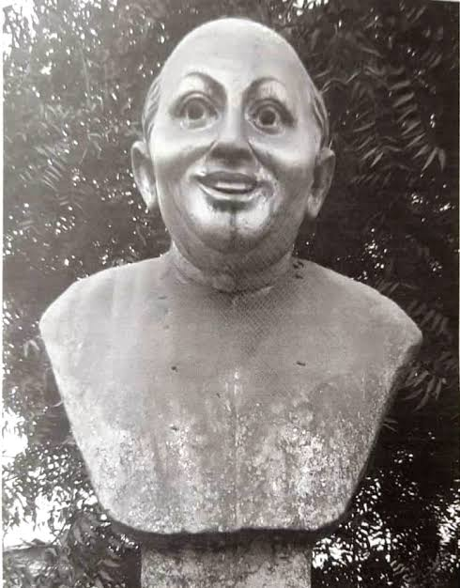

Gopal Bhar was a legendary court jester in medieval Bengal, who served in the court of Raja Krishnachandra, the king of Nadia, during the 18th century. He is widely celebrated in Bengali folklore for his sharp wit, humorous pranks, and clever wisdom. Though there is debate over whether he was a real historical figure or a fictional character, Gopal Bhar remains deeply rooted in Bengali cultural tradition. Known for using humor to expose the arrogance and foolishness of others, Gopal often outwitted scholars, ministers, and even the king himself with his intelligence and presence of mind. His stories, filled with laughter and moral lessons, are still told across generations and are especially popular among children. These tales reflect the values of simplicity, honesty, and the power of common sense. Through his humor, Gopal stood up against greed, pride, and injustice, becoming a symbol of the wise common man. Today, his legacy lives on in books, plays, cartoons, and television shows across West Bengal and Bangladesh, making him a timeless icon of Bengali folklore who continues to entertain and educate people of all ages.

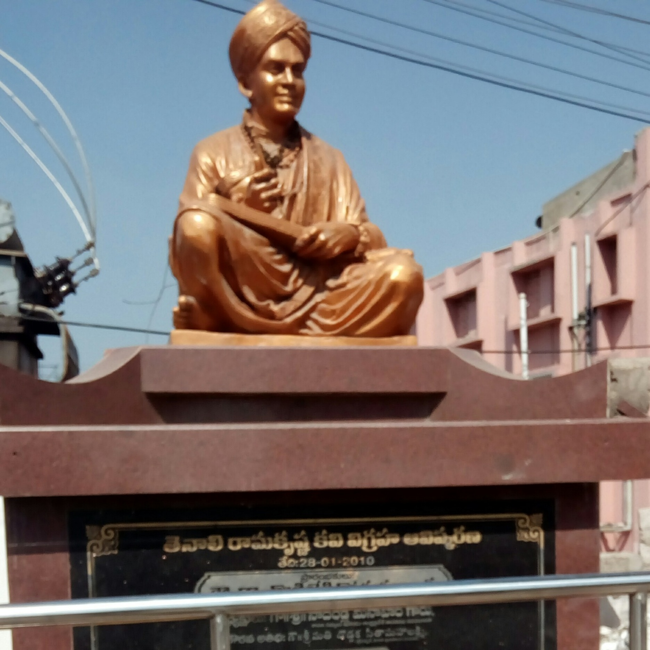
Tenali Raman, also known as Tenali Ramakrishna, was a legendary poet, scholar, and witty court jester in the court of King Krishnadevaraya of the Vijayanagara Empire in the 16th century. Born in a small town called Tenali in present-day Andhra Pradesh, he was renowned for his sharp intelligence, quick wit, and clever problem-solving abilities. Tenali Raman’s tales are famous for their humorous twists and hidden morals, where he often outsmarts arrogant courtiers, greedy traders, and even rival kings using only his wisdom and sense of humor. Despite being a joker, he was respected for his intellect and was often entrusted by the king with serious matters of the court. His stories, originally passed down through oral tradition, continue to be popular in children's books, cartoons, and television series across India. Like Gopal Bhar in Bengal, Tenali Raman is a cultural icon in South India who represents the power of clever thinking, humility, and justice. His legacy endures as a beloved figure who used laughter as a tool for truth and wisdom.
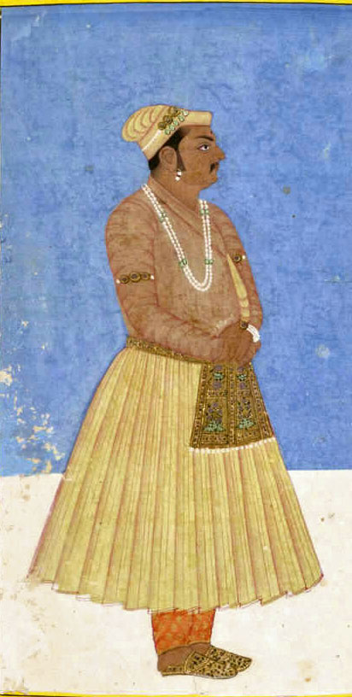
Birbal, whose real name was Mahesh Das, was a famous advisor in the court of the Mughal Emperor Akbar during the 16th century. Known for his sharp intellect, quick wit, and sense of justice, Birbal rose from humble beginnings to become one of Akbar’s most trusted courtiers. He was not only a skilled poet and administrator but also a master of solving complex problems with cleverness and humor. Stories of Birbal highlight his ability to tackle difficult situations, expose lies, and teach moral lessons—often by outsmarting jealous courtiers or cunning people with his calm and witty responses. Akbar admired Birbal deeply and often tested his wisdom through tricky questions and riddles. The tales of Akbar and Birbal, passed down through generations, are still enjoyed today in books, school textbooks, comics, TV shows, and animated series. Birbal remains a symbol of intelligence, honesty, and the idea that wit and wisdom are more powerful than brute strength or status. His stories continue to entertain and educate, making him one of the most beloved figures in Indian folklore.

Wit
Wit is the quick and clever use of words or ideas, often in a humorous or sharp way. It’s about thinking fast and being verbally sharp.

Intelligence
Intelligence is the overall ability to learn, understand, reason, solve problems, and adapt to new situations. It covers a broader range of cognitive abilities.

Satire is when someone makes fun of something serious to point out its flaws or problems, usually to bring about change or awareness.

Meanings

1. Hilsa – A kind of fish, popular and expensive during its season.

2. Discussion – Talking about something with others.

3. Annoyed – A little angry or irritated.

4. Rid of – To be free from something annoying or unpleasant.

5. Exaggerating – Making something seem more important or bigger than it really is.

6. Scolding – Speaking angrily to someone for doing something wrong.

7. Outburst – A sudden expression of strong emotion.

8. Silence – Complete quietness; no sound.

9. Disgrace – Shame; loss of respect.

10. Proclaim – To announce something officially or publicly.

11. Reward – A prize or gift for doing something good or brave.

12. Dare – To do something that takes courage.

13. Strange – Unusual or odd.

14. Resolve – A firm decision to do something.

15. Determined – Strongly decided to do something.

16. Half-shaven – With only one part of the face shaved.

17. Ashes – Powdery remains of something burnt.

18. Ragged clothes – Torn and dirty clothes.

19. Absurd – Completely silly or unreasonable.

20. Curious – Eager to know or learn something.

21. Jeering – Laughing or speaking in a rude or mocking way.

22. Mocking – Making fun of someone.

23. Insane – Mad or mentally unstable.

24. Crowd – A large group of people gathered together.

25. Suspicious – Doubting or thinking something may be wrong.

26. Outrageous – Shockingly bad or unreasonable.

27. Muttered – Spoke in a low or unclear voice.

28. Commotion – A noisy disturbance or confusion.

29. Crazy – Mentally disturbed or acting foolishly.

30. Throw him out – Forcefully remove someone from a place.

31. Majesty – A respectful title used for a king or queen.

32. At once – Immediately; without delay.

33. Brought before – Taken in front of someone (like a king).

34. Courtier – A person who attends a royal court.

35. Ridiculous – Very silly or laughable.

36. Out with it! – Say it quickly; speak up.

37. Fashion – Style of dress or appearance.

38. Strangely enough – Surprisingly; in an unexpected way.

39. Not a soul – No one at all.

40. Challenge – A task or test of someone’s ability or courage.

41. Achieved – Successfully done or completed something.

